Annual General Meeting of
The Gemmological Association of Australia Victorian Division Inc

Venue: GAA House 380-382 Spencer St West Melbourne
Date: Thursday April 15th, 2021 (commencing 6.00 p.m.)

AGENDA
- President to open meeting
- Apologies
- Proxies
- Minutes of last Annual General Meeting of the GAA Victorian Division
- Confirmation of Minutes and Signature of the Chairman
- Business arising from the Minutes
- President’s Report
- Treasurer’s Financial Statement
- Adoption of Financial Statement
- Election of Office Bearers for year 2021
  - President
  - Vice-Presidents (two)
  - Honorary Secretary
  - Honorary Treasurer
- Committee members (10)
- Confirmation of Public Officer / Association Secretary General Business
- Close of Meeting

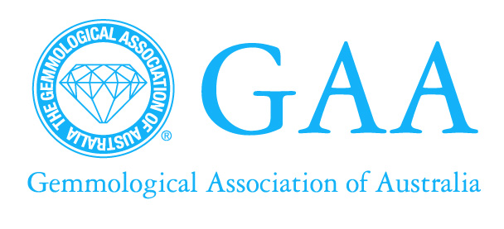 | (VICTORIAN DIVISION Inc.) ABN 41 679 400 853  Association Registration No. A0022481P  380-382 Spencer St, West Melbourne 3003  T: (03) 9326 6160 F: (03) 9326 6150 E: vic@gem.org.au

NOMINATION FORM FOR STATE MANAGEMENT COMMITTEE

I,
wish to nominate:
for the position of:
I, |  |  | second the nomination.
I, |  |  | agree to be nominated for the position as stated above, and if elected, shall attend all meetings regularly.
Date:
Signed:

NOTE: Nominee, Nominator and Seconder must be current financial members of the Victorian Division Inc.

PLEASE NOTE THAT APPLICATIONS MUST BE IN THE HANDS OF THE SECRETARY BY
6:00 p.m, THURSDAY APRIL 15th, 2021



APPOINTMENT OF PROXY – ANNUAL GENERAL MEETING, THURSDAY APRIL 15th, 2021 6.00 p.m.

I,
of
being a financial member of the Gemmological Association of Australia, Victorian Division Incorporated, hereby appoint
of
as my proxy to vote for me on my behalf at the Annual General Meeting of the Victorian Division Incorporated to be held on THURSDAY APRIL 15th, 2021 at 6.00 pm, and at any adjournment thereof.
Signed:

PLEASE NOTE THAT THE APPOINTMENT OF PROXY NOTICE MUST BE IN THE HANDS OF THE SECRETARY NO LATER THAN 6:00 p.m. on THURSDAY APRIL 15, 2021.

